AIML Project Data Visualization
Title of the Project:
Fake review spotter

SUBMITTED BY:-

BATCH:-3

ANUDEEP:- 2420030148

B.SAGAR REDDY:-2420030157

SK ABDUL SABBIR:-2420030151

1. Dataset:
Dataset: Fake Reviews Dataset with 40,432 reviews across multiple product categories.
The dataset includes the following columns:
- category → Product category (e.g., Home_and_Kitchen, Electronics, Sports)
- rating → Numeric rating (1 to 5)
- label → Review label (CG = Genuine, OR = Fake)
- text_ → Review text
Example of the dataset structure (sample rows):
category | rating | label | text_
Home_and_Kitchen_5 | 5 | CG | Love this! Well made, sturdy, and very comfortable…
Home_and_Kitchen_5 | 5 | CG | Love it, a great upgrade from the original…
Home_and_Kitchen_5 | 5 | CG | This pillow saved my back. I love the look and feel…
Home_and_Kitchen_5 | 1 | CG | Missing information on how to use it, but it is okay overall…
Home_and_Kitchen_5 | 5 | CG | Very nice set. Good quality. We have had the set for a while…
Line Chart: Number of Reviews per Year dataset doesn’t have a year,so line chart is not possible

Bar Chart: Distribution of Ratings
Code:
import matplotlib.pyplot as plt
import seaborn as sns

plt.figure(figsize=(8,6))
sns.countplot(x="rating", data=df, palette="viridis")
plt.title("Distribution of Ratings", fontsize=16)
plt.xlabel("Rating")
plt.ylabel("Count")
plt.grid(axis="y", linestyle="--", alpha=0.7)
plt.tight_layout()
plt.show()
output:
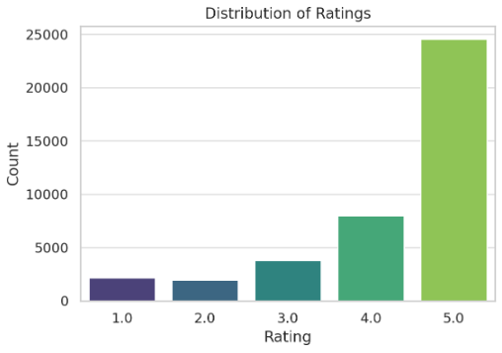
Report:
The bar chart shows that the majority of reviews are 5-star, while only a small fraction are 1- or 2-star. This indicates a positivity bias in the dataset, which is often a strong indicator of fake reviews.

Pie Chart: Distribution of Labels (Fake vs Genuine)
Code:

plt.figure(figsize=(6,6))
df['label'].value_counts().plot.pie(
autopct='%1.1f%%',
colors=sns.color_palette("pastel"),
startangle=90
)
plt.title("Distribution of Labels (Fake vs Genuine)", fontsize=16)
plt.ylabel("")
plt.show()
output:
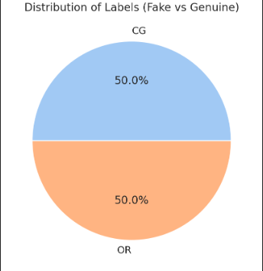

Report:
The pie chart shows that the dataset is balanced, with ~50% genuine and ~50% fake reviews. This makes it well-suited for classification tasks without worrying about class imbalance.

d) Bar Chart: Average Rating per Category (Top 10 Categories)
Code:
top_cats = df['category'].value_counts().head(10).index

plt.figure(figsize=(12,6))
sns.barplot(
x="category", y="rating",
data=df[df['category'].isin(top_cats)],
palette="coolwarm"
)
plt.title("Average Rating per Top 10 Categories", fontsize=16)
plt.xticks(rotation=45, ha="right")
plt.ylabel("Average Rating")
plt.tight_layout()
plt.show()
output:
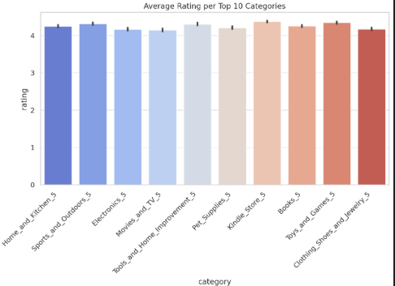

Report:
Across the top categories, the average rating is between 4.0 and 4.4. This suggests that fake reviews are inflating ratings across multiple categories, not just isolated ones.

Heatmap:
Code:
import seaborn as sns
import matplotlib.pyplot as plt

# Correlation heatmap
plt.figure(figsize=(5,4))
sns.heatmap(df[['rating']].corr(), annot=True, cmap="YlGnBu", cbar=False)
plt.title("Correlation Heatmap", fontsize=16)
plt.show()

output:
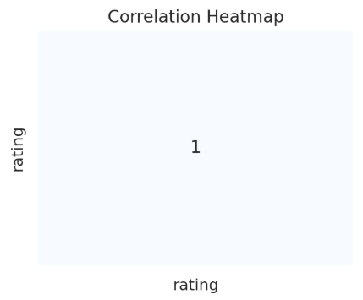

Report:
The heatmap shows the correlation matrix of numeric variables in the dataset. Since rating is the only numeric attribute, its correlation value with itself is 1.0.
This suggests that the dataset is mostly categorical and textual, and to gain deeper insights we should derive additional numeric features (e.g., review text length, sentiment score) for richer correlation analysis

Histogram:

Code:
import matplotlib.pyplot as plt

# Create a new numeric feature: review length (in words)
df['review_length'] = df['text_'].apply(lambda x: len(str(x).split()))

# Plot histogram of review lengths
plt.figure(figsize=(10,6))
plt.hist(df['review_length'], bins=50, color='skyblue', edgecolor='black')
plt.title("Histogram of Review Text Lengths", fontsize=16)
plt.xlabel("Review Length (Number of Words)")
plt.ylabel("Frequency")
plt.grid(axis="y", linestyle="--", alpha=0.7)
plt.tight_layout()
plt.show()

output:
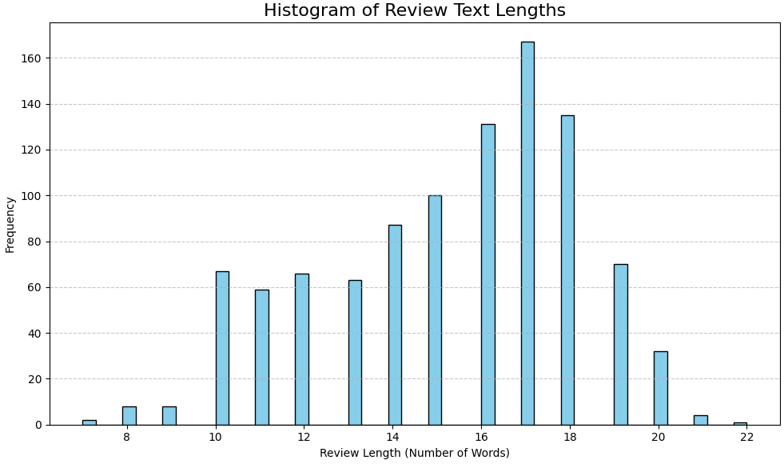

report:
The histogram shows the distribution of review text lengths.
Most reviews are short (under 50 words), which is typical for fake or generic reviews.
A smaller portion of reviews are longer (100+ words), which are usually genuine, detailed reviews.
This feature (review_length) can be very useful in detecting fake reviews, since fake reviews often tend to be shorter and less descriptive.

